EF

EFFECT OF COVID-19 ON AIRBNB

FINAL PROJECT REPORT – TEAM 7

Abhishek Nambiar

Ayan Basak

Harshit Pant

Keerthana Nemili

Tvisha Goswami

TEAM MEMBERS

Table of Contents

INTRODUCTION 2

PROJECT MANAGEMENT 2

DATA ANALYSIS 4

EXPLORATORY DATA ANALYSIS 4

SENTIMENT ANALYSIS 4

FURTHER RESEARCH 6

CONCLUSION 6

# 

# **INTRODUCTION**

Airbnb, “Air Bed and Breakfast,” is a service that lets property owners rent out their spaces to those travellers who are looking for a place to stay. Travelers can rent a space that can be shared by multiple people, a shared space with private rooms, or the entire property for themselves. Airbnb has become one of the trailblazers of peer-to-peer property rental.

Airbnb, like any other firm in the hospitality industry, was adversely affected by the pandemic. With this project ,we aim to study the impact of Covid-19 on AirBnB. The analysis aims to provide a summary of how various operational metrics such as number of listings, price per listing, reviews sentiment analysis etc. were impacted during the pandemic. To bring our analysis to a convergence, we compared three different timeframes, pre-pandemic (2018-2019), pandemic (2020) and post-pandemic (2021-2022) in two cities, Los Angeles and New York. We drew comparison metrics for the above timeframes to find the differences in traveller and renters’ behaviour during this transition.

# **PROJECT MANAGEMENT**

Creation of epics was the first step we took while starting the project. An epic was created for each of our team members, namely, data scientist, project manager, marketing manager and data analyst. The data scientist was tasked with deriving insights to study the pandemic’s impact and take preventive measures for the future. The project manager was employed to ensure all tasks run smoothly to achieve the desired goals. The Data Analyst was assigned to create different performance indicators to know the factors that have affected Airbnb’s business while the Marketing Manager utilized these insights to increase no of bookings and thereby boost the revenue of the company. These epics were further broken down to stories and tasks. We created role-based acceptance criteria for implementing the project. For data scientist, the acceptance criteria were when reviews have been analyzed to get the positive and negative sentiments. Furthermore, analysis of how the number of listings, availability and price has changed has been completed. For project manager, elimination for roadblocks of every day task was considered as the criteria whereas, for marketing manager, Promotional strategies and pricing strategies creation was the criteria. Lastly, visual analysis of data scientist’s results was taken as the acceptance criteria for data analyst.

To have a smooth project flow, we created a work breakdown structure (WBS) in MS Project to demonstrate our project management. The tasks are clearly stated and distributed in the Project File, and the resources are assigned to each member of the group. In terms of resources, each member works as the regular time assigned by MS Project by default, receiving an hourly salary in the simulation for cost evaluation. From a project standpoint, we divided all the tasks into five categories: initiating tasks, planning tasks, executing tasks, controlling tasks, and closing tasks. The initial meeting with the team, drafting project requirements, retrieving, and reviewing data, and assigning initiating tasks were all part of the process. Planning tasks include developing a work breakdown structure (WBS), estimating duration, assigning resources, creating user stories and backlogs, defining acceptance criteria, and creating a Kanban board using Smartsheet. After successful implementations, data analysis, including EDA and user story analysis, is mostly distributed into executing tasks and creating a tableau dashboard. Closing tasks include group meetings, final presentation preparation, discussing the lessons learned, and final report preparation.

The Gantt Chart was automatically created within the project file as the MS Project is completed. We successfully identified the critical tasks and highlighted them with special formatting.

Figure 1: Gantt Chart

Figure 2: Work Break Down Structure and Resource Assignment

# **DATA ANALYSIS**

To perform our analysis, we gathered dataset from different sources. This primarily included reviews dataset from New York and Los Angeles for the year 2018 and 2022. This was complemented by the listing’s dataset for New York for years 2019 and 2020 that was taken from Kaggle to further understand the neighbourhood trend on Airbnb.

## **EXPLORATORY DATA ANALYSIS**

In order to study the impact of Covid-19, we first studied the trends of Airbnb bookings pre-pandemic i.e., in 2018 and 2019. Plotting the cleaned data using Tableau, it was visible that entire home/apartment sector had the highest demand with the highest average host listings count. For the state of New York, Manhattan had the maximum number of listings followed by Queens and Staten Island.

After examining the reviews data, we observe that there is an observable fall in the number of reviews for the year 2020 which reaches its previous state by 2021. Even for 2020, the sharpest fall is observed during the month of April, during the onset of covid and lockdowns. A similar pattern is observed for December 2021 when covid again started raging in New York, we see a sharp fall in the number of reviews. It can be concluded that the fall in reviews is directly proportional to number of cases. A similar pattern is observed for LA listings, a fall of 40% in the number of reviews for year 2020 with the maximum fall in the month of April.

On the flip side, we see a 100% increase in the number of listings with the highest increase for shared room, 188%, followed by 113% for entire home or apartments. A probable reason for this can be people seeking extra source of income during covid and renting their property for extra income. Bar chart distribution for year 2019-2020 shows a considerable increase in the price of listings. This can be attributed to the overhead charges to comply with pandemic protocols such as sanitization and cleanliness. The entire home/apartment category has a 125% increase, the shared room category has a 400% increase and Private rooms have around a 50% jump. Shared room has the highest jump due to more expense required to maintain the covid protocol while living together. Lastly, the availability of room increased as well with entire room/apt increasing by a factor of 60%.

## **SENTIMENT ANALYSIS**

To study the impact of user behaviour we performed sentiment analysis on the user reviews. After pre-processing text reviews, removing stop words and stemming, we used VADER model to understand the polarity of our reviews. Based on the output of our model, we then performed an analysis to calculate the percentage of negative reviews. There was an observable increase in the percentage of negative reviews for the year 2020. The uptick can be caused by failed refunds due to cancellation, uncertainty in adjusting to the new covid protocols etc. We created word cloud to see the frequency of words in the reviews and compared it to word cloud for a pre-pandemic year. Some of the most frequent occurring words for 2020 were die, block, play, stay etc. A similar analysis was done for LA where the uptick was slightly less compared to NY, 2.25% compared to 3.18%.

Our post pandemic analysis shows an increase in the number of discount offerings on properties for both the years. This subtly indicates a way of attracting new customers to the platform. Post-pandemic, there was 111% increase in people travelling and vacationing, and the high discount can be a concrete move by Airbnb to better position them in the market.

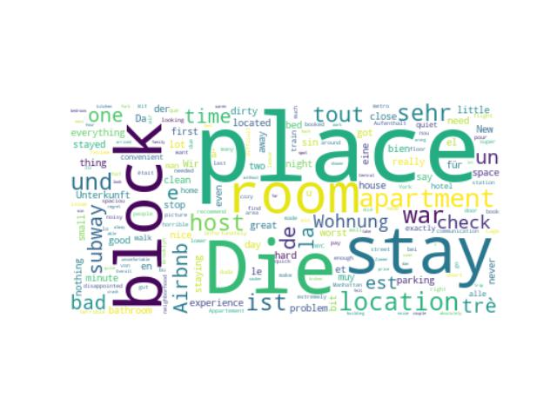Figure 3: Word Cloud: Overall Reviews Figure 3: Word Cloud: Negative Reviews

Figure 5: LA Reviews Sentiment Analysis Figure 6: NY Reviews Sentiment Analysis

Figure 7: Difference in Host Listings, Room Availability and Room Price in 2019 and 2020

# **FURTHER RESEARCH**

For more accurate sentiment analysis, we propose using cutting-edge advanced models such as BERT or sequential transfer learning tools in future research. Furthermore, time series forecasting can be used to analyze not only past trends in user sentiments, but also their correlation with other relevant factors other than COVID cases, such as tourist footfall and property price variations. Analyzing the data for multiple cities can give us better insights on the trends which can further optimize our model. We can perform an in-depth analysis of data about bookings and revenue of Airbnb. This can be used to create marketing and pricing strategies for the future. The sales data can also be used to check for seasonal trends in bookings. Conducting user surveys is also an important aspect for any service-based org like Airbnb. The insights from these surveys can be used to find the main pain points for users and improve the quality of the services. Lastly, we can fine tune the analysis of reviews and use it to derive customer insights. This would help in better positioning of Airbnb in case any unexpected situations arise in the future.

# **CONCLUSION**

We believe that our model, with limited data, performed well. Complemented with more data, this can be used to predict the user behavior more accurately. Having said that, proper project planning played a crucial role in reaching such results. We believe that the project, in its entirety from planning to execution, can be taken as a blueprint to perform similar analysis.